# Business Intelligence Solution (BI Solution)

1. Data Source

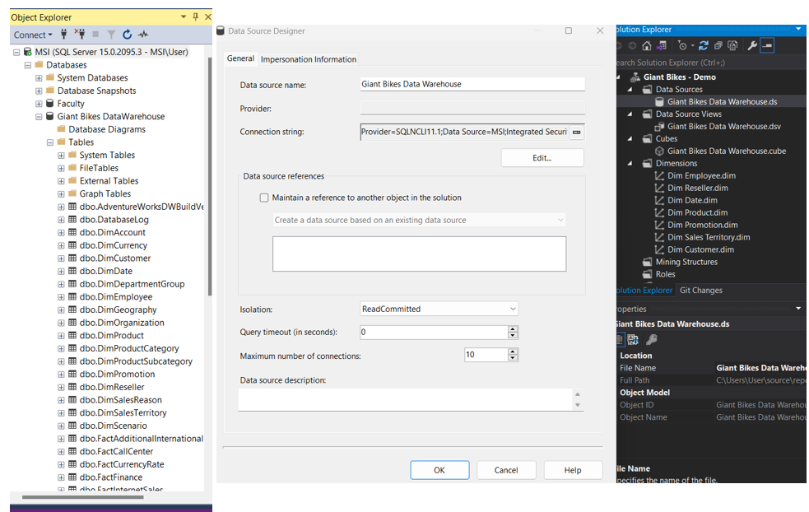

Figure 5: Data Source (Screen shots from SSMS and Visual Studio)

Data source is where all the information of the company had stored. Data source is essential for business intelligence to provide insights for the company. In the data source, it has two type of tables, fact and dimension, where fact table stores measurements information and dimension table store descriptive information. In each of the tables, it has the attributes to be used to satisfy the process of business intelligence.

1. 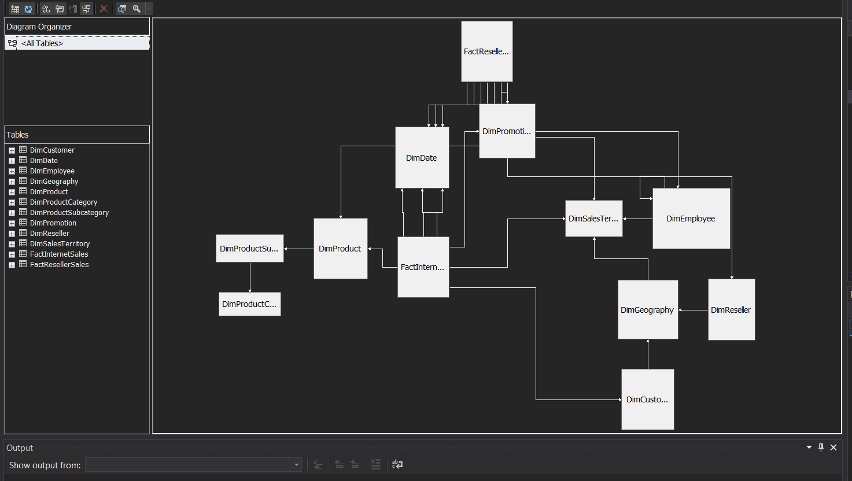Data Source View

Figure 6: Data Source View (Screen Shot from visual studio)

A data source view is a solitary, comprehensive view of the metadata from the assigned tables, including the dimension and fact tables, and views that the data source defines in the project (Minewiskan & john-par, 2022). When the metadata is stored in the data source view, it is possible to work with it during development without having an open connection to any underlying data sources.

1. 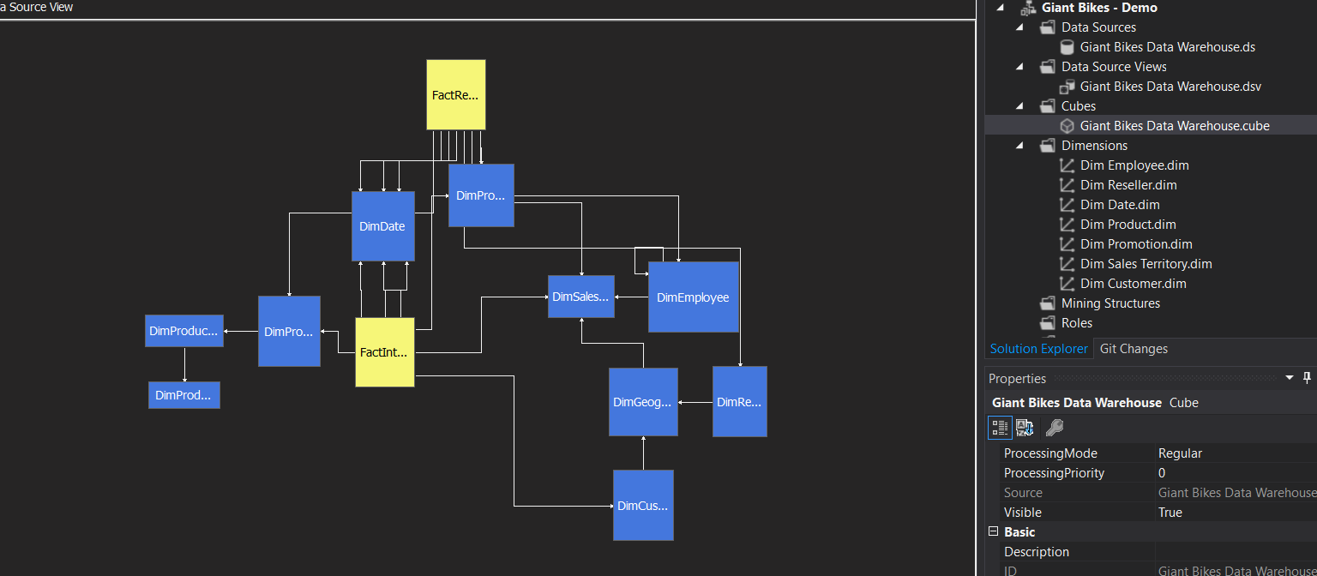Cube Structure

Figure 7: Cube Structure (Screen shot from visual studio)

A cube is a multidimensional structure with dimensions and measurements as its primary building blocks that store data for analytical purposes. Measures offer aggregated numerical data of importance to the user, while dimensions specify the shape of the cube user have been using to break down into smaller parts and analyse in different perspectives in order to gain deeper insights.

1. Usage of Dimensions

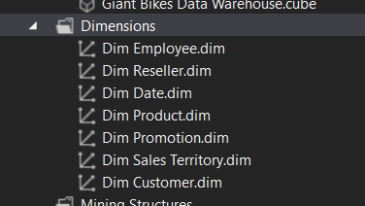

Figure 8: Dimensions (Screen shot from visual studio)

The dimension table will be able to be selected in order to choose the desired attributes for creating visualization purpose in the dashboards.

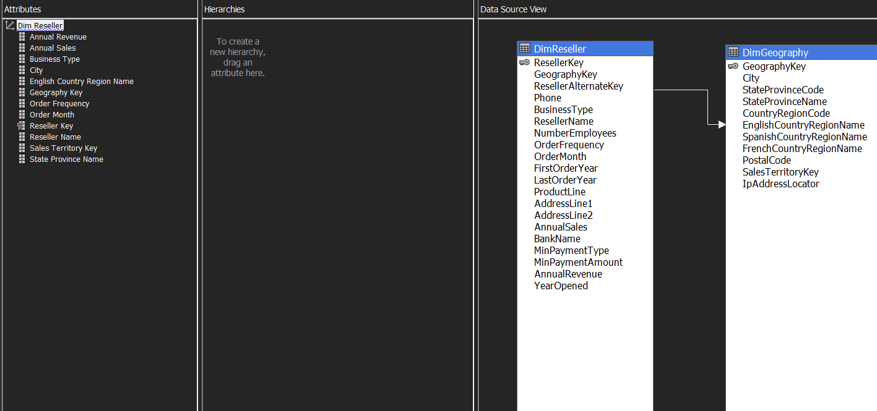

Figure 9: Example of choosing attributes from the dimensions

For an instance, the desired attributes have been chosen and be dragged to the “Attributes” column. Hence, only the chosen attributes will be displayed in the respective fields of power BI.

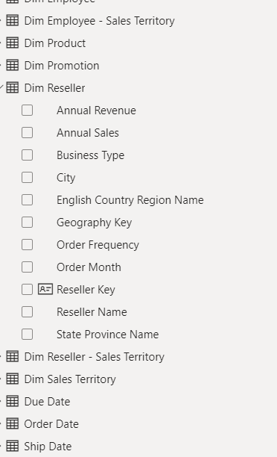

Figure 10: Example of chosen attributes displayed in the respective fields (Screen shot from power BI)